Appendix 'A'

(Cover)

LANCASHIRE STRATEGIC TRANSPORT PROSPECTUS

Connecting Lancashire to an Interconnected North

FOREWORD

Chair of Transport for Lancashire / Chair of Lancashire Enterprise Partnership

CONTENTS

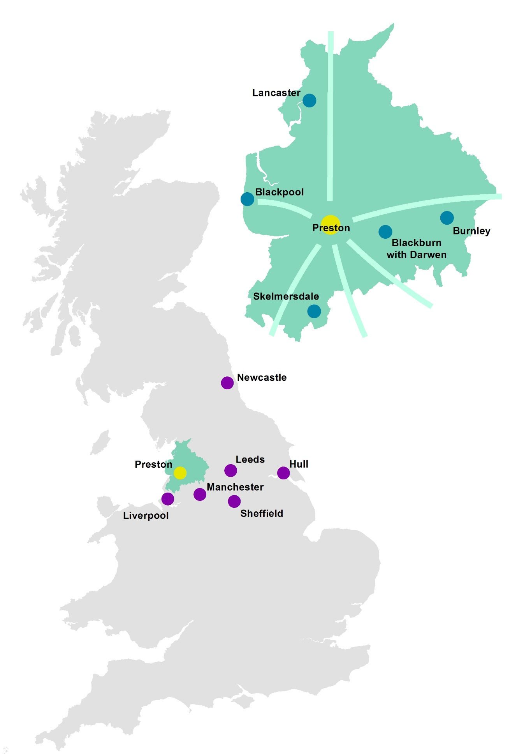
EXECUTIVE SUMMARY

Introduction - An Interconnected North

In June 2014, the Chancellor of the Exchequer set out his vision for a 'Northern Powerhouse', a collection of northern cities sufficiently close to each other that, when combined economically would be able to challenge the World and in so doing, contribute to rebalancing the UK's economy. The Chancellor considers transport to be key to achieving this vision, together with science and innovation, culture and the environment and governance. However, in his view, the transport network in the North is simply not fit for purpose and certainly not good enough to enable cities to pool their strengths. The Chancellor has therefore identified the need for an ambitious plan to make the cities and towns across the North much better connected to create the equivalent of travelling around a single global city.

2014 also saw the publication of a number of reports setting out proposals to improve connectivity to, from and across the North of England, particularly by rail.

In March, Sir David Higgins, the incoming Chair of HS2 Limited, published his initial views on HS2, in which he reaffirmed the strategic case for the Phase 2 extension to both Manchester and Leeds. In doing so, he highlighted that, whilst capacity is an issue in some parts of the North to the same extent as it is in the South, the greater problem is connectivity. Journey times are simply too slow. He therefore proposed the integration of HS2 into the existing rail network to transform connectivity across the North along a corridor broadly stretching from Liverpool and Manchester to Leeds, Sheffield and Hull.

Also in March, the HS2 Growth Taskforce published a report to the Government setting out the challenges faced in maximising the benefits of HS2 and how these challenges could be overcome. Key among the recommendations was that for each HS2 station, there should be an HS2 Growth Strategy setting out how the faster connections and greater capacity will generate local jobs, growth and regeneration. The taskforce also established that HS2 should be at the heart of an effective transport network that can spread the economic benefits of the project as widely as possible between the city regions.

In responding to the challenge to develop a coherent strategic transport plan integrating HS2 with the existing rail network, the five northern city regions (Leeds, Liverpool, Greater Manchester, Newcastle and Sheffield set out the 'One North' high level proposals for a pan-northern multi-modal investment programme. The proposition attracted support from the Chancellor, and the five city regions, together with Hull and the Humber, subsequently commissioned further work to develop the strategic economic case and to refine the programme of strategic interventions into one that would be achievable.

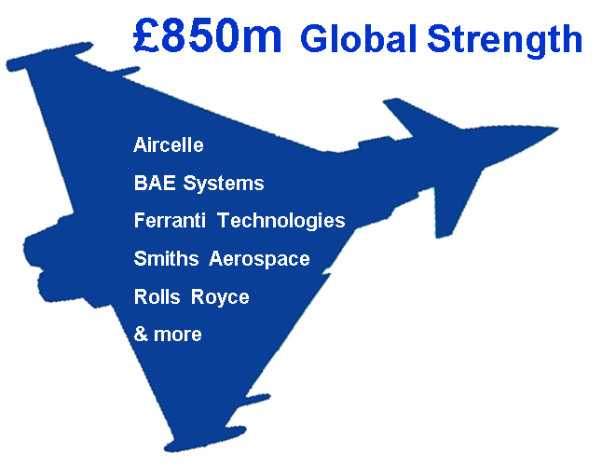

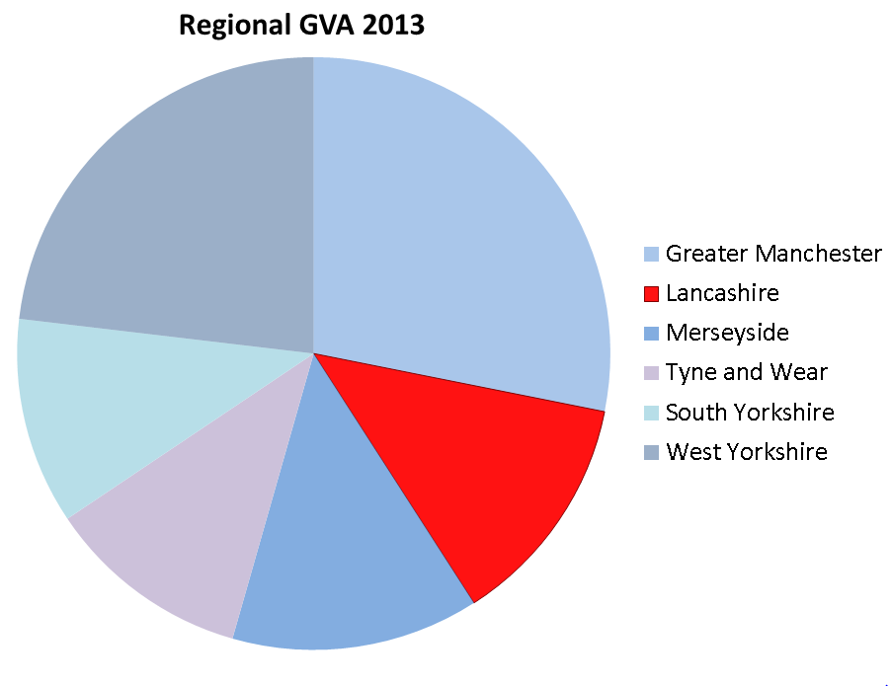

£25.5 bn

In October, Sir David Higgins published a second report, Rebalancing Britain: From HS2 towards a National Transport Strategy, setting out his latest views on HS2 and the 'One North' proposition. Whilst this report is not a statement of Government policy, it nevertheless represents a set of recommendations to the Government, including support for substantially improved east-west connectivity across the North, concluding that significantly improved journey times between the principal cities in the North is as important to the North as 'Crossrail' is to London. The report also recommended that formal arrangements be put in place with a clear remit to turn the 'One North' analysis into reality.

The Prime Minister and the Chancellor subsequently gave their backing to develop 'HS3', a high speed rail link that would significantly reduce journey times between the North's key cities. The Government is now working with a new body, 'Transport for the North', to develop a comprehensive transport strategy to include options, costs and a delivery timescale for HS3. An interim report will be available in March 2015, with a full report scheduled for March 2016.

This document, Lancashire's Strategic Transport Prospectus, confirms why and how Lancashire has a key role to play in this interconnected Northern Powerhouse by providing access to global markets through its advanced engineering and manufacturing capabilities across a wide spectrum of industries, through its developing innovation base and through its large and skilled workforce.

The prospectus then sets out the highway and transport interventions needed for Lancashire to realise that role, which will not only bring substantial benefits to Lancashire, but to the UK as a whole, making the Northern Powerhouse truly 'One North'.

The Northern Powerhouse: Why Lancashire is a Key Component

Lancashire has one of the largest local economies in the North of England, valued at over £25 billion, is home to over 40,000 businesses employing in excess of 670,000 people, and has a population of 1.4 million. It also has a particularly rich and varied economy and geography, from the agriculture and horticulture of the coastal plain through diverse urban areas priding themselves on innovation in engineering and manufacturing to dramatic moorlands above heritage industrial towns that are reshaping themselves for the 21st century.

Lancashire has experienced sustained growth in the last decade, with readily identifiable economic 'hotspots' such as the cities of Preston and Lancaster, and we are now the second largest economy in North West England and one of the biggest in the North; only Greater Manchester and Leeds at the heart of the Northern Powerhouse are significantly bigger. Our world-leading aerospace sector alone contributes £850 million to the economy, while a core of ambitious SMEs is geared up for growth. They are supported by the extensive research and development facilities of major employers and the region’s three universities. Increasing economic growth across the Northern Powerhouse can only benefit Lancashire and vice versa.

Over the last 3 years, the Lancashire Enterprise Partnership (LEP), working with Lancashire's 15 local authorities, county, unitary and district, has brought forward a comprehensive economic strategy to underpin Lancashire's future growth. That work has built on Lancashire's already significant contribution to key sectors of the UK economy and paved the way for both the Preston, South Ribble and Lancashire City Deal and the subsequent Lancashire Growth Deal. These deals will not only lead to a major expansion of Lancashire's economy but will expand Lancashire's role in providing a vital contribution to the Northern Powerhouse.

The Preston, South Ribble and Lancashire City Deal agreed with the Government builds on the strong economic performance of the area over the last ten years and will help to ensure that the City Deal area continues to grow by delivering new jobs and housing. Over a ten-year period the Deal will generate:

- More than 20,000 net new private sector jobs, including 5,000 in the Lancashire Enterprise Zone;
- Nearly £1 billion growth in Gross Value Added (GVA);
- 17,420 new homes; and
- £2.3 billion in leveraged commercial investment.

The overarching purpose of the Lancashire Strategic Economic Plan and Growth Deal is to re-establish Lancashire as an economic powerhouse and a national centre of excellence in advanced manufacturing by maximising its clear competitive strengths and capabilities in the aerospace, automotive, energy and health science related sectors. The Strategic Economic Plan will harness the power and potential of Lancashire's national industrial hotspots and key strategic sites, its key clusters of high value activity and its internationally recognised centres of excellence in research and innovation.

With a tradition in the aerospace, advanced manufacturing and nuclear sectors, Lancashire already has a strong platform on which to develop, sustain and grow business and industrial

Advanced engineering and manufacturing:
- Global aerospace sector unique in the North
- Lancashire Advanced Engineering and Manufacturing EZ
- Automotive including high vale OEM supply chains
- M65 Growth Corridor, with the largest concentration of employment in advanced manufacturing in England
- Advanced chemical and polymer presence
Energy:
- Strong nuclear industry presence – power generation and fuel production
- Internationally recognised centres of excellence in energy and environmental studies.
- Logistics support to one of the largest offshore gas fields in UK waters.
- Key location bringing offshore electricity onshore to connect with the National Grid
- Energy HQ – national specialist training for onshore and off shore energy
Innovation:
- Health Innovation Park - new facilities for product and service development collaborating with the University
- New Engineering Innovation Centre (EIC) of international standing at UCLan
- New Centre for Quantum Technology Innovation (Lancaster University)
- New Cyber-Security Innovation Centre (Lancaster University)
Business and Finance:
- Growing financial and professional service sector
- Business process outsourcing - already includes industry leaders
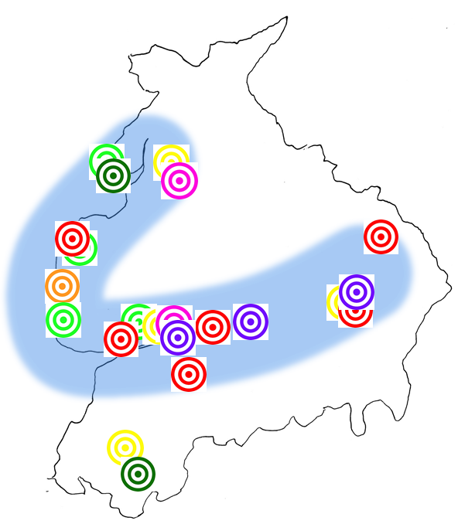
- 'Near-shoring' opportunities where costs can be contained whilst still providing access to a skilled workforce.
Tourism:
- Blackpool - UK's largest seaside resort ,17 million visitors per year
Logistics and Distribution:
- Heysham - Nationally important asset for Irish Sea freight transportation
- Heysham - supply base for major offshore gas fields and wind farms in the Irish Sea.
- Skelmersdale - proximal to Atlantic Gateway corridor, excellent access to the motorway network
Top Universities:
- Lancaster, Preston and West Lancashire

clusters of international importance, as independent economic analysis has shown. These sectors, which have the potential to deliver a scale of growth, will have a transformative impact on the northern economy:

- Lancashire is central to a regional cluster of aerospace capability which is recognised as the fourth largest in the world. One of three key clusters of aerospace capability in the UK, it is the only one in the north of England. As a result of inherent sector strengths and specialisms, Lancashire provides a world class development opportunity for the Northern Powerhouse as a whole, enabling companies to be at the heart of the county's nationally significant aerospace supply chain.

- The automotive sector has an important base in Lancashire. Again the supply chain is significant, with the majority of business activity focussed on the supply of high value parts to UK and European Original Equipment Manufacturers (OEMs), a key Lancashire capability that the UK as a whole is seeking to grow. Exploiting a legacy of testing facilities, Lancashire also has a significant cluster of innovative design and development companies, including Torotrak, Clean Air Power and Scorpion Automotive, on which to build.

- Lancashire’s close proximity to a number of Nuclear Decommissioning Authority sites makes it an ideal central location from which to serve the industry. Also, the Springfield Fuels site has the capability and capacity to manufacture fuel for all designs of nuclear reactors worldwide. The specific strengths of Lancashire's nuclear sector, if properly linked with key assets and opportunities in Cumbria, Manchester, Cheshire and Sheffield, creates the potential for establishing a coherent sector industrial and skills strategy for the North of England under the overarching direction of the Nuclear Advanced Manufacturing Research Centre (NAMRC) based in Sheffield.

Further market specialisms also have the necessary pre-requisites to grow into significant employment and value generating sectors in the future, and again the Northern Powerhouse can both benefit from and be key to their development. These sectors include health (including the Lancaster Health Innovation Park), unmanned aerial vehicles, digital (cyber security, big data and sector specific software applications), and business process outsourcing. These latter sectors in particular have a particular synergy with the rest of the Northern Powerhouse as well as complementing Lancashire's existing key business and financial services sector.

Lancashire's innovation assets are internationally recognised and will be critical to supporting future economic growth through world-class research, knowledge transfer and innovation. Lancashire has one of the largest concentrations of university assets in the North, comprising Lancaster University, the University of Central Lancashire (UCLan) based in Preston and Edge Hill University in West Lancashire. Lancaster is also home to the largest campus of the University of Cumbria.

Lancaster University is a world renowned academic institution, consistently ranked amongst the top 10 UK universities for research and teaching, and is ranked number 1 for physics research. The University continues to grow and now has over 11,000 students, with an international profile which will see the university establish industrial links with key international markets. UCLan is the 5th largest university in the country in terms of its undergraduate in-take and was the first modern UK University to be ranked in the prestigious QS World Rankings. By combining the research excellence and industry capacities of Lancaster University and UCLan, the LEP is developing an innovation programme that can deliver a step-change in local economic performance.

Lancashire also boasts an outstanding further education (FE) and vocational offer, capable of meeting all skill needs; the county is the only LEP area in the country where all FE colleges and locally-based training providers are recognised as good or outstanding.

Why Transport is our Key Priority

Whilst Lancashire has benefitted in recent years from key transport and infrastructure schemes of national significance such as the West Coast Route Modernisation programme completed in December 2008, apart from the completion of the Heysham to M6 Link Road due to open in summer 2016 and the Pennine Reach public transport scheme in East Lancashire, there has been a collective failure to secure investment needed for critical local transport infrastructure over recent decades. This failure, it is estimated, accounts for one-quarter of Lancashire's current economic performance gap with the rest of the UK.

To address this key barrier to growth, the LEP has established two specific economic development initiatives:

- Transport for Lancashire (TfL) is a fully functioning and dedicated committee of the LEP. TfL has provided for the first time the opportunity to align strategic transport investments with agreed economic and housing growth priorities. TfL is now working with key partners to guide delivery of a transport investment programme across Lancashire worth over £300m; and

- A series of Highways and Transport Masterplans are nearing completion to cover the whole of Lancashire. A key output is the identification of schemes critical to unlocking economic and housing growth opportunities across Lancashire, an approach that has underpinned the development of the successful Preston, South Ribble and Lancashire City Deal and helped shape the Strategic Economic Plan and its subsequent Growth Deal.

The principle behind these masterplans is simple. If the current highways and transport situation and all future plans and priorities that will affect it are understood, then the improvements that are required, and opportunities that may be available to fund them, will become apparent. These improvements and opportunities are, in each masterplan, guided by an area specific vision based on a common set of guiding principles:

- Transforming Lancashire's economy will benefit everyone; our residents and businesses will prosper as will those we share our economic fortunes with, particularly in the North. Connectivity, both within and outside the county is key to our plans to grow.
- We can no longer plan modes independently. We must have a truly integrated highways and transport plan for both people and freight that will provide a long term strategy to support a transformed economy. That means we must look to the long term impacts and viability of service provision as more roads will not be an option.
- Rail travel offers a solution for longer journeys and demand for rail is growing across Lancashire if there are better standards of service; greater connectivity, greater integration of services, better rolling stock and infrastructure.
- Our agenda is transformational; major capital expenditure will be required, as justified by economic benefits.
- We must make the best use of available resources and prioritise those investments that deliver the best overall return by stimulating economic transformation.
- Lancashire must take full advantage of investment beyond the county. HS2 and the North’s interconnected city regions will together make the North a new destination of choice for mobile businesses; Lancashire's international and national connections make it well placed to both benefit from this and to make the North's offer more attractive.

An ineffective transport network constrains economic growth and the potential to deliver new employment and housing. Better connectivity, reducing congestion, developing a reliable and efficient public transport network, unlocking strategic employment sites and linking to neighbouring growth areas and important national and international markets are all vital to transforming economic growth in Lancashire.

So seriously does the LEP take Lancashire's transport issues that Lancashire's Growth Deal is specifically designed to establish, for the first time, a transport investment programme, under the direction of TfL, commensurate with Lancashire's economic and housing growth opportunities and challenges.

The investment programme will ensure key locations can fulfil their potential as growth corridors and major industrial, commercial and transport hubs for Lancashire as well as neighbouring economies in the Northern Powerhouse. It will also maximise the connectivity within the Powerhouse to opportunities afforded by new national and regional initiatives, including HS2, Airport City, Media City UK, Northern Hub, Atlantic Gateway and Liverpool SuperPort.

The Strategic Economic Plan recognises that places such as Skelmersdale, in West Lancashire, and Rossendale, in East Lancashire, are equally capable of taking advantage of their location adjacent to growth opportunities in neighbouring city-regions, especially in Liverpool and Manchester. The Growth Deal positions the connectivity solutions necessary to maximise these key cross-boundary opportunities.

The economic benefits of transformational positive change to our highways and transport networks is established. In Lancashire, these changes will not only be inward looking though; we have set out in this prospectus why our own proposals are in synergy with the wider One North proposition. Since the benefits will be in synergy too and will impact across the Northern Powerhouse, we reiterate them.

Better connectivity means improved journey time reliability, better travel quality and shorter journeys that will widen and strengthen the North’s labour markets and improve business efficiency by:
- Stimulating business investment and innovation by supporting economies of scale and new ways of working;
- Achieving agglomeration economies by bringing firms and their employees closer to business rivals and partners;
- Enabling firms to access a larger labour supply and providing wider employment opportunities for workers and those seeking work;
- Increasing competitiveness through access to new and larger markets with the benefits of increased labour market specialisation;
- Reducing trading costs and using more efficient logistics networks; and
- Strengthening the existing comparative advantages of the North as a place to do business.

All these things mean a more productive northern economy, which means higher wages, profits and tax receipts for the Exchequer.

Our Transformational Agenda

The five highways and transport masterplans that underpin our transformational agenda have been produced to coincide with the five distinct economies of Lancashire. Each of these areas has been studied, their future plans and priorities identified and a vision developed of how a genuinely integrated highways and transport system will support the specific requirements of each area.

Central Lancashire has Preston, Lancashire's principal city, at its heart. Preston is the most significant transport hub in the county, providing most of the county's connections to the West Coast Main Line and, in the future, to HS2. The Preston, South Ribble and Lancashire City Deal will see Central Lancashire transformed, with 20,000 new jobs and over 17,000 new homes. Whilst our growth sectors will account for many of these jobs, Preston's business and financial sector will also expand. Add to this the University of Central Lancashire, already growing and reconfiguring to place itself truly in the heart of the city, and the need for high quality, effective inter-city connectivity has never been stronger. It will be vital for business, whether based in Central Lancashire or further afield, that accessing Lancashire is straightforward and not compromised by problems on the road and rail networks of the North.

Lancaster holds one of Lancashire's greatest assets in its universities, with Lancaster University being one of the country's top teaching and research institutes, in the top 1% of global universities. That emphasis on research makes Lancaster a key hub for innovation and so connectivity for business and academia is a particular need and with major expansion proposed around the University to the south of the city's historic centre, new infrastructure will be critical to ensuring effective access to the motorway network. Lancaster is also home to the major port of Heysham, a key facility for Irish Sea Ro-Ro traffic between the UK mainland and Northern Ireland, the Isle of Man and the Irish Republic. Completion of the £130m Heysham to M6 Link Road in the summer of 2016 will significantly improve the port's access to the Strategic Road Network, but for the port to reach its potential, the Strategic Road Network across the North must be effective.

East Lancashire has a growing portfolio of higher value industries with aerospace, advanced manufacturing, advanced flexible materials, digital and creative industries all featuring strongly in the area's economy, making it key to both the Enterprise Zone and to the Arc of Prosperity. The area also has the potential to be a sought after commuter area for the Northern Powerhouse. With the quality of many local rail services and infrastructure leaving much to be desired, there is a significant identified requirement for greatly enhanced rail connectivity, with higher speeds, greater frequency and better rolling stock quality to enable East Lancashire to link into and support both Lancashire's growth and that of neighbouring areas such as Manchester. The area's motorway gateways are also pivotal to supporting our ambitions, again both for Lancashire as a whole and for its role in the wider northern economy.

The Fylde Coast is one of the most affluent areas in Lancashire, containing towns and rural areas popular with commuters, with the advanced engineering and manufacturing sector providing highly paid jobs that underpin local economies. With the nationally significant resort of Blackpool central to the area, with a visitor economy that is revitalising, supported by recent substantial investment, it is not surprising that leisure and tourism are important components of the economy. Ensuring the Fylde Coast links in effectively to the strategic road and rail networks is therefore vital and will become even more so as the Northern Powerhouse develops and once HS2 is operational.

West Lancashire, despite its fundamentally rural nature, is home to a number of international and nationally recognised companies and Edge Hill University, which has been named University of the Year in the 10th Annual Times Higher Education Awards for its exceptional performance and innovation. Lying between major growth areas in Central Lancashire, Liverpool and Manchester, attractive, high quality rail connections will be a must going forward. Skelmersdale, with two junctions on the M58 that are within easy reach of the M6, provides the perfect location for logistics and distribution companies; better connectivity within the town and, critically, by rail to nearby city regions, will allow the town to grow and fulfil its true economic potential, enabling residents to commute across Manchester and facilitating West Lancashire's role in the growth of SuperPort.

Lancashire's role as part of the Northern Powerhouse is clear, providing key international and national growth sectors, a nationally significant university based innovation asset, a large and highly skilled workforce in most areas of the county and a high quality of life for residents who choose to commute to larger cities.

Our transformational agenda is therefore not just critical to Lancashire, for Lancashire to grow in isolation from the rest of the North, but critical for Lancashire to grow far more strongly as part of the Northern Powerhouse and for the Northern Powerhouse to reap the benefits of Lancashire's offer.

Our agenda is explained in more detail below, but has reached the same conclusion as the wider 'One North' proposition. We need high quality, high speed connectivity to other cities and we need our 'city region' networks to interconnect to these high quality intercity services.

Our Transformational Agenda Explained

Part 1: Our Transformational Priorities

National Connectivity: Connecting to HS2

Preston lies approximately mid-way between Glasgow and London on the West Coast Main Line, and also has regular direct services to Manchester, Manchester Airport, Birmingham, Edinburgh, Leeds and Liverpool, as well as servicing more local centres including Blackpool, Blackburn and East Lancashire, Lancaster and the Lake District. The railway station is a critical asset for the city and also acts as a gateway to Lancashire and for communities further north for local, regional and national connectivity. With over 4.5 million passenger users annually and a further 1.3 million interchanges, Preston is the busiest station in the North West outwith Manchester and Liverpool city centres.

As a key economic centre in its own right and identified by Government as such, it is vital that Preston has direct and frequent access to HS2 and potentially HS3 in fit for purpose surroundings. However, the station fabric has seen little investment in recent years resulting in a poor passenger experience and preventing the station from contributing towards the wider commercial development of the city centre. The station needs transforming into a modern, 21st Century facility from which, to which and through which passengers can pass in comfortable surroundings, one that will encourage greater rail use and fully maximise the inherent advantages of Preston's location on the rail network. Such a transformation will also help to enhance the station's presence within the city centre and its relationship to existing and proposed business district development.

The significance of Preston Station as a driver of economic growth is recognised by stakeholders both within and outside Lancashire. As such, the station's development is of fundamental importance to the economic growth aspirations across Lancashire, and in so doing, particularly once HS2 becomes operational, will reinforce Preston's role as the North West's major rail hub north of Manchester. Establishing an HS2 Growth Strategy as recommended by the HS2 Growth Taskforce for Preston will be an important element to achieving this. In addition, Network Rail has requested the City and County Councils prepare a long term vision for the station to inform its strategic review of West Coast Main Line capacity north of Crewe.

From a Lancashire perspective, whilst the recommendation from Sir David Higgins to accelerate delivery of an HS2 Hub at Crewe in 2027 rather than 2033 as originally planned is welcomed, it is essential that a connection from HS2 to the West Coast Main Line further north is retained. The recommendation to review this connection in light of concerns raised through consultation is noted, as is Sir David's assertion that such a link will be necessary sooner rather than later as part of the wider consideration of how to improve services to Scotland. Lancashire also wishes to see this link considered in conjunction with the proposed wider examination of east-west connectivity across the North including HS3 / 'Crossrail North'.

Inter City Region Connectivity within the Northern Powerhouse

The Northern Hub, due for completion in 2018, will address capacity and network constraints on the rail network in and around Manchester and when considered alongside completion of electrification between Manchester / Liverpool and Preston / Blackpool will deliver a significant improvement in terms of connectivity and capacity in the key corridors linking parts of Lancashire with Manchester and Liverpool city centres and Manchester Airport.

At the heart of the 'One North' proposition is a proposal for a new 200kph (125mph) Trans-Pennine rail connection that would deliver 30 minute journey times between Manchester and Leeds and Sheffield city centres. The route would also serve Manchester Airport directly and link with the north-south HS2 line on the eastern side of the Pennines between Leeds and Sheffield.

Preston to Manchester Rail Corridor

The rail corridor linking Preston with central Manchester and Manchester Airport is not only of strategic importance to Lancashire but also to Cumbria and Scotland, and the transport strategy for the North needs to reflect this. Connections are available in central Manchester for onward travel to a range of other key destinations across the North, including Leeds and Sheffield. Electrification works between Preston and central Manchester are due to be completed by December 2016 and modern electric rolling stock has already been introduced on Trans-Pennine Express services between Scotland and Manchester Airport, which currently travel via Wigan North Western. However, significant overcrowding remains on some services between Preston and Manchester, particularly those originating in Scotland / Cumbria / Blackpool that continue through to Manchester Airport.

Although the Government announced more diesel powered carriages for selected services in the corridor in January 2015, it will be essential to ensure that the advantages electrification will deliver in terms of improved quality of service are not squandered. Recent economic and employment growth in Lancashire has been strongest with this corridor, with parts of Central Lancashire in particular seeing strong employment growth. It is also the corridor with the greatest opportunity to grow the business travel market in Lancashire and in tandem to reduce congestion on the parallel M61.

M6 and M61 Motorways

The M6 is an integral part of the UK’s main north-south transport spine between London, the West Midlands and Scotland, which also includes the West Coast Main Line. From a Lancashire perspective, it is particularly important for the movement of freight, for example, to and from the Port of Heysham. South of Preston, deterioration in the operational effectiveness of the route is resulting in increased average journey times and a worsening of journey time reliability. This is likely to have a damaging effect on freight operations, many of which function on the basis of ‘Just in Time’ delivery. Lancashire therefore welcomes the commitment in the Road Investment Strategy to upgrade much of the M6 south of Junction 26 (the M58 west of Wigan) to Smart Motorway by 2019/20.

Even with full delivery of the schemes set out in the Central Lancashire Highways and Transport Masterplan, evidence suggests that the M6 Preston Bypass will be under pressure by 2026, particularly during peak periods between Junctions 30 and 32 with the M61 and M55 respectively. This length of the M6 already has four lanes in each direction, so at some stage the potential to introduce 'Smart Motorway' technology will need assessing. Possible scheme elements could include access controls at junctions and variable speed limits. For consistency, Lancashire would therefore wish to see the 'smart spine' linking the North West and London referred to in the Road Investment Strategy ultimately extend as far north as Junction 32.

The M61 links the M6 at Preston with the M60 Manchester Outer Ring Road and the Trans-Pennine M62. Although existing traffic flows are generally within the capacity of the road, the M61 Corridor is heavily used by commuters, and significant congestion with long queues of standing traffic occurs during the morning peak period on the southbound approach to the M60 at Junction 15 as traffic attempts to access Manchester City Centre via the A580 and other destinations via the M60. Lancashire therefore has a strategic interest in both the operational effectiveness of the M60 as this provides access to and from Manchester Airport via the M56 and Yorkshire and eastern England via the M62. Consequently, the Manchester North West Quadrant Study proposed in the Road Investment Strategy is of particular importance to Lancashire.

Cross City Services: Connecting Lancashire to City Region Networks

The 'One North' proposition is not just about travel between city regions. It also includes the development of city region rail networks that provide the additional capacity required to sustain city centre growth. These networks will interconnect with HS2, new intercity services across the North and metro/tram systems, supported by much expanded park and ride facilities. They will require electrification, new rolling stock (a matter of urgency for the North in terms of quality and sufficiency), higher service frequencies, new services and the removal of network pinch points. Development of European style cross city region networks centred on hub stations is a key aspiration.

East Lancashire Rail Network

In East Lancashire, a number of improvements to the rail network have either been delivered or are programmed, for example, the recently completed upgrade to Burnley Manchester Road station and the forthcoming introduction of a new direct train service between Blackburn, Accrington, Burnley and Manchester Victoria via Todmorden and Rochdale. The County Council and Blackburn with Darwen Borough Council are also working with Network Rail to deliver a scheme to improve the reliability and frequency of rail services on the route between Clitheroe, Blackburn and Manchester Victoria. This is now a funded scheme within the Lancashire Enterprise Partnership's transport investment programme, subject to demonstrating value for money.

Whilst the above developments will bring about some improvement to the rail network in East Lancashire, they will not address the fundamental issue of whether or how the rail network can contribute towards a transformational change in East Lancashire's economic fortunes. East Lancashire is perceived as an area that is poorly connected with a transport network that hinders the efficient movement of both people and goods, and that this relative isolation has a negative impact on economic development and impedes regeneration. The East Lancashire Rail Connectivity Study has examined this issue in depth, in particular, the importance of enhanced connectivity between East Lancashire and the growth centres of Preston and Central Lancashire, Manchester including Manchester Airport, and Leeds.

East Lancashire's rail network is relatively constrained in terms of connectivity, capacity, performance, journey quality journey times and passenger facilities, and without investment is likely to have a negative impact on future economic growth, particularly given recent announcements of rail improvements elsewhere across the North, as people and businesses would be less likely to locate in the area. The current deficiencies can make rail an unattractive mode of travel; consequently, use of the rail network in East Lancashire is relatively low compared to neighbouring areas, including between East Lancashire and neighbouring city regions. If the existing rolling stock is not improved or replaced, then the quality and reliability of the trains will deteriorate further with time, which could deter existing rail passengers from continuing to use the train, placing additional pressure on the highway network.

The Rail Connectivity Study, which adopted a Conditional Outputs approach, has identified that improving service frequency and journey times within East Lancashire would deliver the greatest level of benefit. Whilst the realisation of each output will be subject to the identification of an affordable and value for money solution, it is clear that electrification of the routes between Preston and Leeds / Colne and Clitheroe / Blackburn and Bolton together with associated rolling stock improvements would make the most significant contribution.

Skelmersdale

Whilst Skelmersdale enjoys excellent strategic connectivity to the Strategic Road Network via the M58, the local transport network is no longer capable of supporting current economic growth aspirations, with a road network that is not fit for purpose, inadequate public transport provision, lack of provision for pedestrians and cyclists and an inhospitable public realm. The West Lancashire Highways and Transport Masterplan adopted by Lancashire County Council in October 2014 is therefore proposing the wholesale reconfiguration of Skelmersdale's transport networks to meet both current and future needs, not just for local residents and businesses but for West Lancashire as a whole.

This is a transformational proposal and once in a generation opportunity to reshape Skelmersdale through a single programme of works spread over a number of years to ensure that the town has a sustainable, integrated transport network that will allow it to grow and prosper in the future. At is heart is a new rail link and town centre railway station fully integrated with the bus network and easily accessible on foot or by cycle, and with sufficient car parking provision to function as a 'Parkway' station for the wider West Lancashire area. The station would be served by a new spur from the existing Wigan Wallgate to Kirkby line, enabling through services to operate to both Liverpool (via Kirkby) and Manchester (via Wigan), and hence provide direct access to growth opportunities in both city centres and potentially at Manchester Airport and the Airport City Enterprise Zone. Furthermore, the new station and interchange is intended to act as a catalyst for the wider redevelopment and growth of Skelmersdale town centre. The Skelmersdale Rail Link also features in the Liverpool City Region Long Term Rail Strategy published in August 2014.

Lancashire County Council and its partners Merseytravel and West Lancashire Borough Council commissioned Network Rail to undertake a GRIP Stage 1-2 (output definition / feasibility) study to develop the proposal set out in the masterplan, including indicative costs. This work has now concluded. The County Council also commissioned Jacobs UK limited to undertake an assessment of the likely value for money and wider economic benefits of the proposal commensurate with a Strategic Outline Business Case and the Accountability Framework of the Lancashire Enterprise Partnership.

The work undertaken to date has demonstrated that it is technically feasible to construct a heavy rail link into Skelmersdale town centre in the corridor identified in the adopted West Lancashire Highways and Transport Masterplan, and that the project could deliver value for money. The County Council and partners anticipate that a scheme could be delivered during the next rail industry investment period covering 2019 to 2024 (known as 'Control Period 6'), although most likely financed through the Local Growth Fund, and are currently establishing appropriate governance and working group arrangements to oversee the future development of the project once a commitment to fund the next stages in the GRIP process (option selection and single option development) is forthcoming.

Skelmersdale is best placed in Lancashire to take advantage of the opportunities presented by the development of the Liverpool SuperPort concept, a key priority for the Liverpool City Region Strategic Economic Plan. The Atlantic Gateway initiative, a collection of assets including transport infrastructure that represents an opportunity for growth, lies just to the south. As such, Lancashire is supportive of proposals in the recently published Road Investment Strategy to deliver a comprehensive upgrade of the main link between the Port of Liverpool and the motorway network at Switch Island.

PART 2: Our Key Supporting Infrastructure Priorities

Central Lancashire

New Ribble Crossing: The Central Lancashire Highways and Transport Masterplan included a longer term (post 2026) proposal to construct a new crossing of the River Ribble to link together the Preston Western Distributor and the South Ribble Western Distributor via a completed Penwortham Bypass to provide a continuous dual carriageway route between Cuerden and the M55 to the west of Preston. Delivery of these schemes has been accelerated through the Preston, South Ribble and Lancashire City Deal; therefore, the County Council and partners are investigating whether a new crossing could progress more quickly and how such a project might be funded.

East Lancashire

M65 East Lancashire Gateway: The M65 plays an essential role in the economy of East Lancashire, connecting people and businesses internally as well as providing the primary means of access to Central Lancashire and the M6, particularly for freight. Unlike most motorways, the M65 is not three lanes throughout its length, with reduced capacity on some sections, particularly between the M61 and Junction 6 at Whitebirk. Traffic has grown consistently by around 4% per annum since the motorway's completion in 1997, and evidence now suggests that the current level of demand at peak times is causing congestion, with some junctions at or near capacity.

The predominantly two lane section between the M61 and Whitebirk is increasingly likely to become a bottleneck, reducing the ability of the M65 to function as a major gateway to East Lancashire. Through the East Lancashire Connectivity Study, Lancashire County Council and partners are investigating whether and when additional capacity on the M65 between the M61 and Whitebirk might become necessary and how it might be provided. This work is expected to conclude by summer 2015.

M66 East Lancashire Gateway: As part of the East Lancashire Connectivity Study, Lancashire County Council and partners are undertaking a study to examine the importance of enhanced connectivity in the M66 corridor to Rossendale and the rest of East Lancashire and to identify how best to achieve this enhanced connectivity if there is demonstrable evidence that investment will deliver significant wider economic benefits for East Lancashire and Rossendale in particular. The study scope includes the Strategic Road Network and relevant routes into Manchester city centre, the 'Metrolink' line between Bury and Manchester Victoria and the national rail network between Rochdale and Manchester Victoria. The study is also considering what form a commuter rail link between Rawtenstall and Manchester could take, as there are a number of potential solutions to rail provision in the corridor. Given the concern locally that congestion in the M66 corridor is now acting as a constraint on economic growth and social opportunities, the study is also assessing the wider economic, social and distributional benefits and Gross Value Added uplift of any potential transport investment. The study is expected to conclude in spring 2015.

West Lancashire

Ormskirk to Preston Rail Electrification: Merseyrail currently operates a fast and frequent electric train service between Liverpool and Ormskirk. Travel onwards to Preston requires a change of train to a diesel-operated service that is infrequent and run to an irregular timetable. Rolling stock quality is also poor. Electrification of the Ormskirk to Preston route with appropriate infrastructure enhancements would resolve the majority of issues, significantly improving connectivity between Preston, West Lancashire and the Liverpool city region. In addition, there is the potential to provide better interchange between Liverpool-Ormskirk-Preston and Manchester-Wigan-Southport services at Burscough. Both are aspirations in the Liverpool City Region Long Term Rail Strategy published in August 2014.

Fylde Coast

Blackpool North Interchange (Talbot Gateway): Blackpool's new central business district development (Talbot Gateway) is located adjacent to Blackpool North station, the new offices opening up opportunities for commuting by rail. Blackpool North is also the key gateway to the resort for longer distance travellers but for such a major arrival point, the actual experience on offer is not good.

The Tramway is to be extended from the Promenade to the station, significantly improving public transport connectivity for both residents and visitors. Seamless interchange between the rail network and the tram system will be achieved, providing rail-borne access between the railway station with its newly electrified trains and the Fylde Coast’s attractions and hotels. It is therefore essential that a high quality, multi-modal transport interchange be established at this vital location in support of wider interventions set out in the Lancashire Growth Plan for the renewal of Blackpool.

South Fylde Line: The consultation draft Fylde Coast Highways and Transport Masterplan identifies the South Fylde Line (Blackpool South to Kirkham and Preston via Lytham St Annes) as a key weakness in the Fylde Coast public transport network. The potential of the line could increase significantly if possible connections with the Blackpool Tramway are considered. Lancashire County Council has recently become a partner in the European SINTROPHER (Sustainable Integrated Tram-based Transport Options for Peripheral European Regions) project. The Council has secured funding to investigate the best way of enhancing the role of the South Fylde Line in providing a southern gateway to Blackpool and to establish what the most viable and cost-effective way of linking the South Fylde Line and the Blackpool Tramway might be and what benefits such a link might deliver. The study is due to report by June 2015.

A585 Corridor: The A585 between Fleetwood and the M55 is currently part of the Strategic Road Network and therefore managed and maintained by the Highways Agency. Its strategic role as part of an inter-regional route between Great Britain and Northern Ireland ceased with the withdrawal of the Ro-Ro ferry service from the Port of Fleetwood to Larne in December 2010. The A585 nevertheless remains a key route within the Fylde Coast highway network and is vital to the regeneration of Fleetwood and the success of the Hillhouse International Business Park at Thornton.

As part of its Pinch Point Programme, in 2014/15 the Highways Agency will deliver significant improvements at the A585/A586 'Windy Harbour' junction near Singleton and the A585 junctions with Bourne Way and West Drive between Thornton and Cleveleys at a combined cost of £3.1m. Congestion nevertheless remains an issue at a number of other locations, in particular, the Five Lane Ends traffic signals at Little Singleton, which is arguably the worst remaining bottleneck on the on the route and a difficult location at which to make a significant improvement. The Roads Investment Strategy published on 1st December 2014 includes a commitment to deliver a new, off-line bypass of Little Singleton to reduce the impact of traffic on the local community and remove the bottleneck.

The A585 needs to operate as effectively as possible along its entire length. The County Council will therefore work with the Highways Agency to identify a programme of cost effective, viable improvements to remove any remaining pinch-points on the route, in particular, the unimproved length between the M55 and the Windy Harbour junction.

Lancaster

Lancaster South: The area immediately to the south of Lancaster has been identified as one capable of delivering significant development, critical to meeting the future housing and employment growth needs of Lancaster and which will deliver wider economic benefits to Lancashire and beyond. It lies adjacent to Lancaster University and includes major housing sites at Bailrigg and Whinney Carr as well as the site of the planned Health Innovation Park, an agreed priority in the Lancashire Growth Deal. Jointly these sites are capable of delivering up to 2,000 houses, circa 40,000m² of business and innovation space accommodating over 4,000 high-value jobs and circa 5,000m² of retail and leisure space.

Releasing the development potential of south Lancaster, including the Health Innovation Park, is severely constrained by the existing highway network, with the main access route (the A6) already operating close to capacity. A comprehensive transport solution is therefore required, including strategic and local highway improvements. This could include a reconfiguration of M6 Junction 33 to support both south Lancaster and implementation of a City Centre Movement Strategy post completion of the Heysham to M6 Link Road. Key objectives for the Movement Strategy are to secure an attractive, healthy and safe local environment that contributes to the economic and social wellbeing of the city, its residents and visitors, and to reduce the environmental and social impacts of traffic to the benefit of pedestrians and cyclists and make city centre attractions more identifiable.

Lancaster to Morecambe Rail Electrification: Electrification of the short length of route between the West Coast Main Line north of Lancaster and Morecambe would significantly enhance the town's connectivity in conjunction with the ongoing electrification programme across the North West thereby allowing the resort to benefit fully from the wider 'Connected North' agenda.

BROAD TIMESCALES FOR DELIVERY

By 2021

- Preston, South Ribble and Lancashire City Deal Highway Improvements*
- Preston to Manchester Rail Corridor Improvements to provide additional capacity and better quality rolling stock
- Blackburn to Bolton Rail Corridor Improvements to provide additional capacity*
- Blackpool Tramway Extension North Pier to Blackpool North Station*
- Blackpool North Interchange (Talbot Gateway)
- A585 Corridor Improvements, including a bypass of Little Singleton*

By 2026

- Preston Railway Station / HS2 Interchange
- New Ribble Crossing
- East Lancashire Rail Network Transformation, including electrification and better quality rolling stock
- M65/M66 East Lancashire Gateway Improvements
- Skelmersdale Rail Link and Town Centre Transport Interchange
- Lancaster South Supporting Infrastructure
- Lancaster to Morecambe Rail Electrification

By 2031

- 'Smart Motorway' technology extended northwards along the M6 to Junction 32
- Ormskirk to Preston Rail Electrification
- South Fylde Line Enhancements

*Funding commitment

Speech delivered by the Rt Hon George Osborne MP at the Museum of Science and Industry in Manchester, 23rd June 2014
HS2 Plus, A report by Sir David Higgins, Chair of HS2, March 2014
High Speed 2: Get Ready, A report to the Government by the HS2 Growth Taskforce, March 2014
One North – A Proposition for an interconnected North, (Greater Manchester, Merseyside, South Yorkshire, West Yorkshire and Tyne & Wear) July 2014
Rebalancing Britain; From HS2 towards a national transport strategy, October 2014
Lancashire Strategic Economic Plan: A Growth Deal for the Arc of Prosperity, Lancashire Enterprise Partnership, March 2014
Strategic Commercial Development Advice, Colliers, 2014. This advises that defining what a cluster constitutes is not an exact science but there are indictors which can give an idea as to whether a cluster is present; these include the geography of where companies are based and their proximity to one another, the number of companies based in a certain geographic area and the size and levels of employment of companies.
Rebalancing Britain; From HS2 towards a national transport strategy, October 2014
It is almost as quick to travel from Preston to Leeds by changing trains in Manchester as it is to use the direct service via Burnley and Bradford.
Road Investment Strategy, Department for Transport, December 2014
Road Investment Strategy, Department for Transport, December 2014

